# Passive First order RC Filters

## Low pass filter

### Methodology

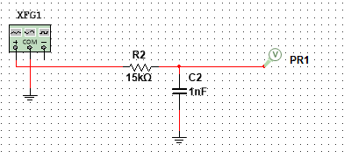

Figure shows a passive RC low-pass filter. The values of the components were chosen because they match with circuit #1 of the D3000 board, “filters”. The input signal generator was set to a sinusoid input of 20Vp-p while the frequency was increased. The cut off frequency was calculated, and frequency and phase sweeps were carried out on the filter.

### Results & Analysis

Eqs. show the cut-off frequency for the low pass filter designed above. This is the frequency at which the gain starts to drop.

|  |  |
| --- | --- |
| $$fc=\frac{1}{2πRC}$$ | () |
| $$fc=\frac{1}{2π×15000×(1×{10}^{-9})}$$ | () |
| $$fc=10.61 kHz$$ | () |

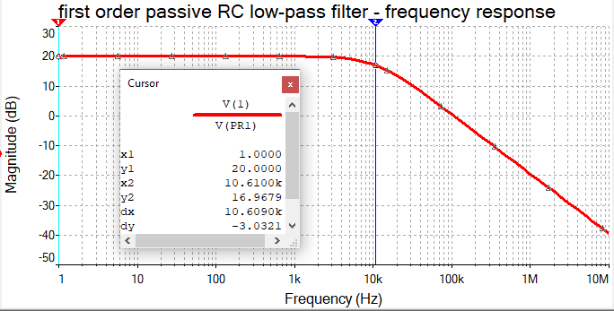

Figure shows the frequency response of the filter. Cursor 1 was left in the pass-band area while cursor 2 was moved to the cut-off frequency. The calculation for the cut-off frequency is correct because it can be observed visually that the gain is starting to drop for frequencies > 10.61kHz, but also the cut-off frequency is known as the point where the gain drops by 70.7% or -3dB; shown by the “dy” line in the window.

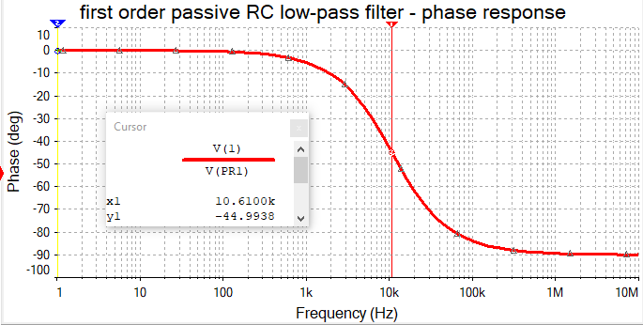

Figure shows the phase response of the filter. As expected, at the cutoff frequency, the output sinusoid has a -45-degree phase shift with respect to the input sinusoid. It is important to note that the initial phase angle is shown to be 0 and tends towards -90 degrees.

## High pass filter

### Methodology

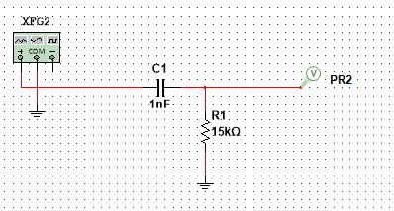

Figure shows a passive RC high-pass filter. The values of the components were chosen because they match with circuit #1 of the D3000 board, “filters”. The input signal generator was set to a sinusoid input of 20Vp-p while the frequency was increased. The cut off frequency was calculated, and frequency and phase sweeps were carried out on the filter.

### Results & Analysis

Since the resistor and capacitor values are the same, this meant that the cut-off frequency was the same as the low-pass filter, 10.61kHz.

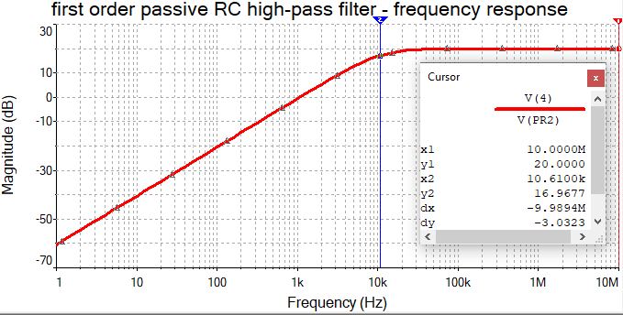

Similarly, the frequency response for the low-pass filter, cursor 1 was left in the pass-band area while cursor 2 was moved to the cut-off frequency. It can be observed visually that the gain is starting to drop for frequencies < 10.61kHz, and as explained for the low-pass filter, it is also the point at which the gain is -3dB; shown by the “dy” line in the window.

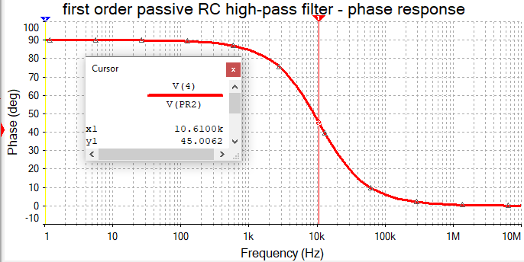

Figure shows the phase response for the high pass filter. The shape is the same as the phase response for the low-pass filter, and like the low pass filter, the phase angle at the cut-off frequency is 45 degrees, as shown in the window. It was observed in the phase response of the low-pass filter that the initial phase angle was 0 and tended towards -90 degrees. However, it can be seen that for a high-pass filter the initial phase angle is 90 and tends towards 0 degrees.

# Active Second order Sallen-Key filters

## Low pass filter

### Methodology

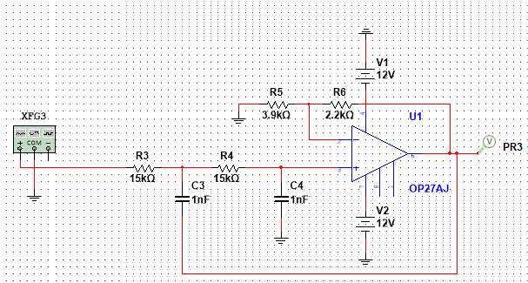

Figure shows a second order Sallen-Key RC low-pass filter. The values of the components were chosen because they match with circuit #1 of the D3000 board, “filters”. The input signal generator was set to a sinusoid input of 2Vp-p while the frequency was increased. The cut off frequency was calculated, and frequency and phase sweeps were carried out on the filter.

### Results & Analysis

Once again, the resistor and capacitor values are the same as the passive filters, this meant that the cut-off frequency was also 10.61kHz.

The mid-band gain was determined by the gain of the non-inverting amplifier stage, shown by Eqs.

|  |  |
| --- | --- |
| $$A_{v(arithmetic)}=1+\frac{R_{6}}{R_{5}}$$ | () |
| $$A_{v(arithmetic)}=1+\frac{2200}{3900}$$ | () |
| $$A_{v(arithmetic)}=1.564 V/V$$ | () |

The arithmetic gain was then converted into dB gain, this was the pass-band gain of the frequency response; given by Eqs.

|  |  |
| --- | --- |
| $$A_{v(dB)}=20\log_{10}{(A_{v(arithmetic)})}$$ | () |
| $$A_{v(dB)}=20\log_{10}{(1.564)}$$ | () |
| $$A_{v(dB)}=3.8853 dB$$ | () |

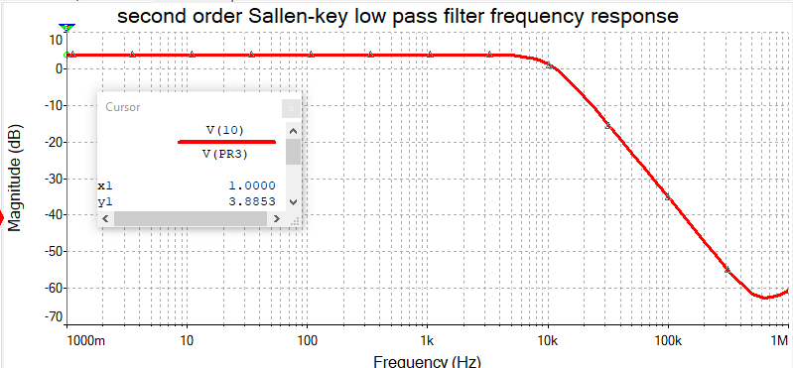

Figure shows the frequency response for the second order Sallen-Key low-pass filter. It is confirmed that the pass-band gain is 3.8853dB, as calculated.

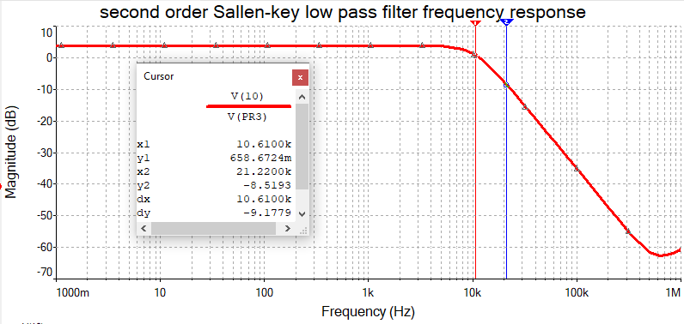

Figure once again shows the frequency response for the same filter, cursor 1 has been placed at the cut-off frequency of 10.61kHz and cursor 2 has been placed one octave above, 21.22kHz. The slope should be -12dB/octave as it is a second order filter, however, it appears to have a slope of -9dB/octave.

## High pass filter

### Methodology

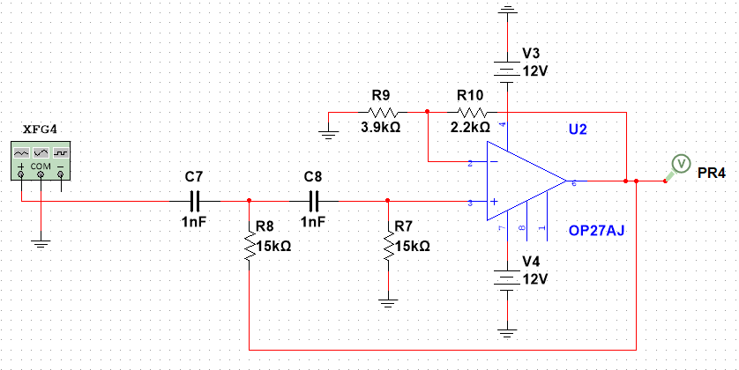

Figure shows a second order Sallen-Key high-pass RC filter. It is almost identical to the low-pass variant except that it is a high pass filter meaning that the resistors and capacitors are switched. Once again, the frequency sweep was carried out. As the components are the same value, this means that the cut-off frequency and the mid-band gain are the same as on the Sallen-Key low-pass.

### Results & Analysis

## low pass filter with mid-band gain of 3

### Methodology

### Results & Analysis

# More complex filters

## Fourth order low pass Sallen-key filter

### Methodology

### Results & Analysis

## Second order band-pass Sallen-key filter

### Methodology

### Results & Analysis

## Second order band-reject Sallen-key filter

### Methodology

### Results & Analysis